Playbook For standard configurations

Create one playbook :

[root@ansible ansible-automation-platform-setup-bundle-2.2.0-7]# vim standand.yml



[root@ansible ansible-automation-platform-setup-bundle-2.2.0-7]# vim standand.yml

---

- name: install apache

hosts: 192.168.0.138

tasks:

- name:

yum:

name: httpd

state: latest

- name: use replace module

ansible.builtin.replace:

path: /etc/httpd/conf/httpd.conf

regexp: "Listen 80"

replace: "Listen 82"

- name: selinux port change

community.general.seport:

ports: 82

proto: tcp

setype: http_port_t

state: present

- name:

service:

name: httpd

enabled: true

state: started

- name:

ansible.posix.firewalld:

port: 82/tcp

permanent: yes

# immediate: true

state: enabled

- name:

file:

path: /var/www/html/index.html

mode: 0644

state: touch

setype: httpd_sys_content_t

- name:

lineinfile:

path: /var/www/html/index.html

line: "welcome world"

state: present

- name:

systemd:

name: httpd

state: restarted

enabled: yes

- name:

community.general.selinux_permissive:

name: httpd_t

permissive: true

:wq!

[root@ansible ansible-automation-platform-setup-bundle-2.2.0-7]# cat standand.yml

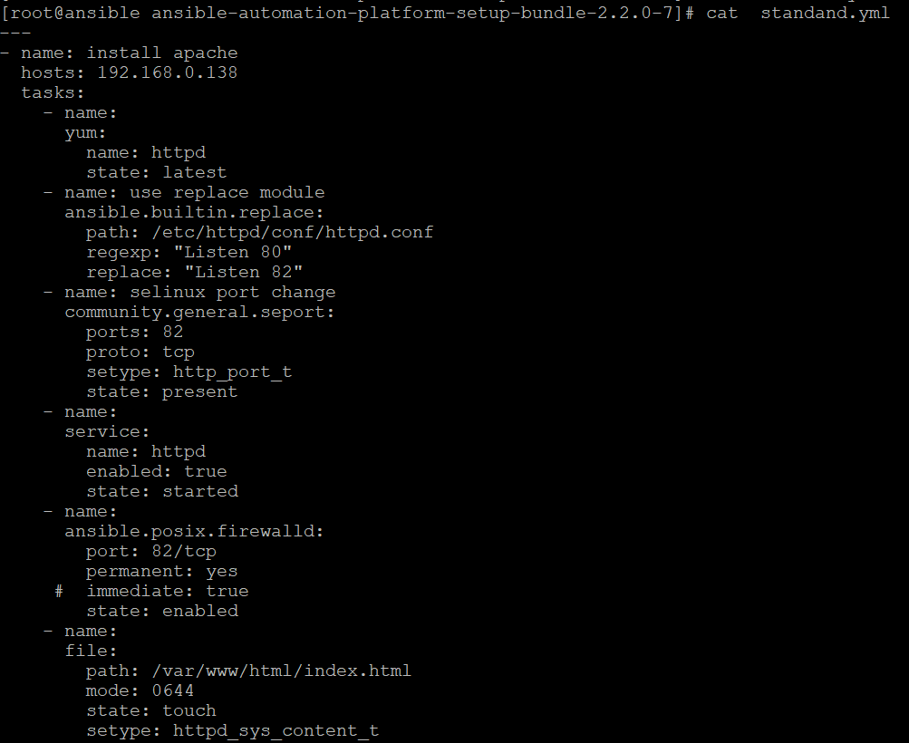

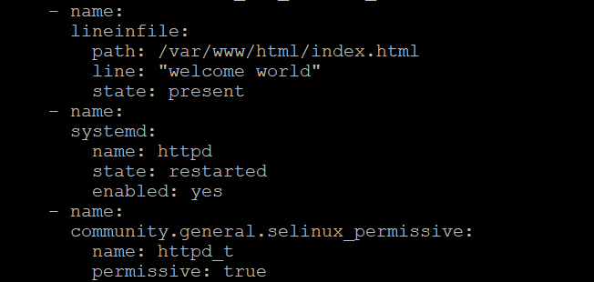

Now run the playbook

Output

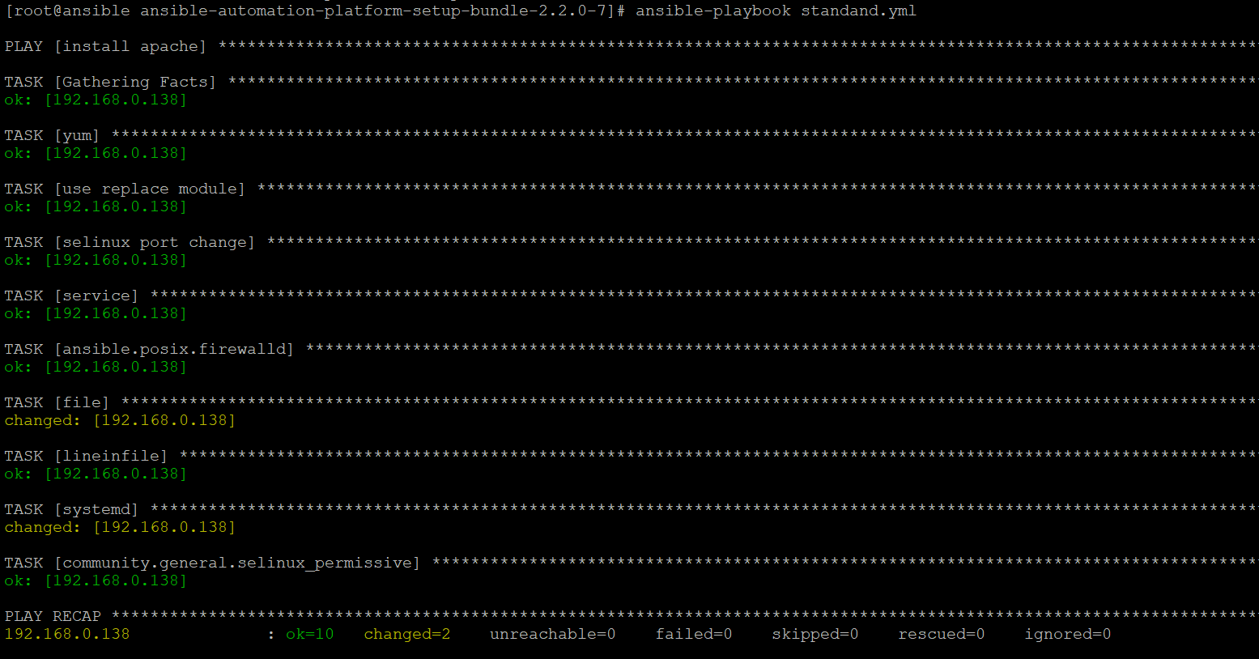

Output

[root@ansible ~]# curl 192.168.0.138:82

